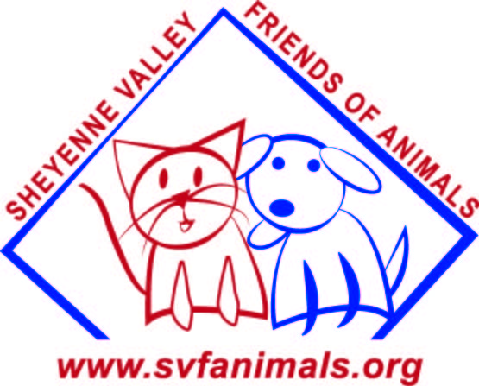 SVFA Foster Care Application
Thank you for taking time to fill out this application. Your information will be kept confidential and will only be used within the organization.

Name: _______________________________________________________________________________
Full Address: _________________________________________________________________________

____________________________________________________________________________________

Email: ______________________________________________________________________________

Home Phone: __________________________ Cell Phone: ___________________________________

Work Phone: __________________________ Best Time to Call: _______________________________

Preferred method of communication: □ Email or □ Phone

Does anyone in your household have allergies? □ Yes or □ No To: □ Dogs or □ Cats or □ Both

How many people are in your household (including self)? Adults: ______ Children under 21: _______

and Ages if under 21: ________________ Who will primarily care for the animal? __________________

Do you □ Rent or □ Own your home? If you rent, do you have permission from your landlord to foster?

Landlord’s Name: ___________________________ Phone Number: ______________________________

Please list your current pets:
Pet name | Dog or Cat | M/F | Age | Up-to-date on vaccinations | Spayed or Neutered?
Please list others on the back.

Is your yard fenced? □ Yes or □ No

Are you willing/able to hold animals overnight, over a weekend, or during an emergency? □ Yes or □ No

What types of pets are you interested in fostering?
Dogs:
□ Large dogs □ Small dogs □ Puppies □ A mother and puppies □ Senior/Special needs
□ A specific breed? _______________________

Cats:
□ Adult cats □ Kittens □ A mother and kittens □ Senior/Special needs

Where will the foster pet be kept when you are at home? (E.G. loose in the house, in a kennel):

_______________________________________________________________________________________________

Where will the foster pet be kept when you are not at home (E.G. loose in the house, in a kennel):

_______________________________________________________________________________________________

Foster pets will not be placed where they will be kept outdoors except in certain cases.

How many hours a day will the foster pet be left alone? _________________________________________________

Do you object to a home inspection prior to placement of animals in your care? □ Yes or □ No

How would you describe your experience with pets? □ Never had a pet □ Had pets as a child □ Had one or more pets as an adult □ Had experience with powerful dogs □Had experience with pets with medical problems □ Previous foster/rescue experience □ Had experience with pets with no training

What situations do you feel unprepared for? □ Excessive barking □ Destructive behaviors □ Not housetrained
□ Escaping □ Shy or fearful behavior □ High activity level □ Administering medications
□ Kennel training □ Not good with children or other pets

- I agree that I will provide the best care possible to the foster pets put in my care.
- All foster animals have been vetted before being placed with me unless otherwise noted. I will contact SVFA with any concerns or questions I have regarding the health of the animal.
- I understand that SVFA has taken reasonable care to screen animals for placement, but makes no guarantee relating to the animals health, behavior, or actions. I am aware of some but not all of the more common diseases associated with animals including rabies. Rabies is included because of its severity and because SVFA does not know what diseases the animals may have been exposed to prior to becoming part of the SVFA program.
- I also understand that SVFA will be monitoring the placement of the animal and has the right to remove the animal at its discretion.
- I understand that everything my foster pet may need, including food, dishes, toys, vet care and follow up care, and other necessities will be provided. Anything I provide will be considered a donation to SVFA which is tax deductible.
- I also agree that if I am not able to provide further care for the foster pet, there is an emergency, or I have a question regarding care, I will contact SVFA immediately.
- Since most SVFA animals come from unknown backgrounds, no guarantee can be made concerning their health or temperament. I release SVFA from any responsibility regarding the health or temperament of the animals placed in my foster care.

Signed__________________________________________________ Date_________________________

