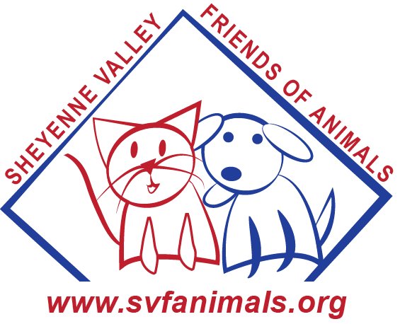
A donation to the Sheyenne Valley Friends of Animals is a great way to personally honor the memory of a loved one or pet while helping area animals. Your donation will help us continue our line of work by helping promote humane and responsible pet ownership and assisting animals in need of care. Remember that your donation is also tax deductable.
If you wish, SVFA will send a card in recognition of your donation to the people you indicate below. You’ll also receive a thank you note as acknowledgement of receipt of your donation.
If you would rather just make a donation, please fill out the information below and leave the lower portion of this form blank.
Donor Information
Name:
Mailing Address:
City: State: Zip:
E-mail address:
Amount: $
In Memoriam Of (name)
Name:
Please send a card to:
Name:
Mailing Address:
City: State: Zip:
Special Instructions:

Please make checks payable to Sheyenne Valley Friends of Animals or SVFA and mail to
PO Box 432, Valley City, ND 58072. Thank you for being a Friend of Animals!

